Example Codicil – please take this form to your Solicitor

I .................................................................................................. (Full Name)

Of...................................................................................................................

................................................................................................ (Address)

declare this to be a codicil to my Will dated ...............................................

In addition to any legacies given in my said Will I give to The Bridge Youth Project, PO Box 1833, Salisbury, Wilts SP4 8HH, registered charity no: 1034800 the sum of £ .......................... or .................% of my estate and/or ................................. (a specific item) to be used for its general purposes and I declare that the receipt of the Treasurer or duly authorised officer shall be a full and sufficient discharge. In all other respects I confirm my said Will and any other codicils thereto.

Signed ....................................................................................................

Signed by the above named in our presence and witnessed by us jointly in his/her presence

Signature........................................ Signature..............................................

Name ............................................. Name .................................................

Address.......................................... Address .............................................

.................................................... ..........................................................

................................................... .........................................................

Occupation .................................. Occupation..........................................

Date ........................................... Date .................................................

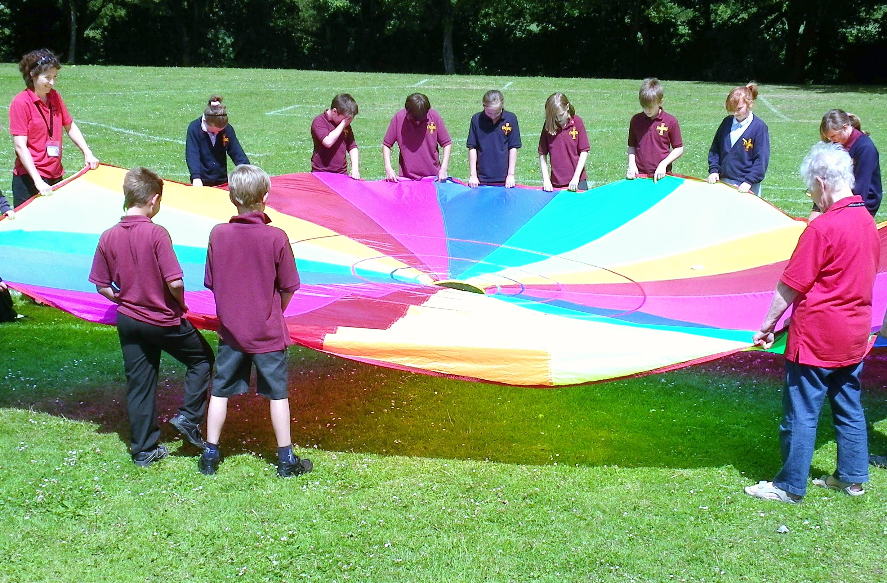

A gift in your Will could help change young people’s lives forever

Faith in Young People, Faith in Education

www.the-bridge.org.uk
office@the-bridge.org.uk
Tel: 01980 655521
Registered Charity No. 1034800



Our vision for the future

How you can help us
After you have provided for your family and friends, perhaps you might consider leaving a gift in your Will to The Bridge. This need not be a large sum but any gift will greatly help us to reach future generations of children with the Christian message. Our methods of communication and ways of serving schools may change with time, but our aims and purpose will remain the same.
Shaun is a young man whose life was changed through his contact with The Bridge. He first remembers The Bridge coming into his primary school when he was 9. He was impressed by members of the team and in his early teens decided he wanted to become a Christian, despite not coming from a Christian family.
He says: “Without the support The Bridge gave me, my life would be very different – I’d probably just be dossing around and not doing a lot.” Now in his twenties, Shaun is still a committed Christian and church member.

Through our schools ministry work in both primary and secondary schools we want to give many more children and young people of all ages the opportunity to hear the good news about Jesus Christ and how he can change their lives.

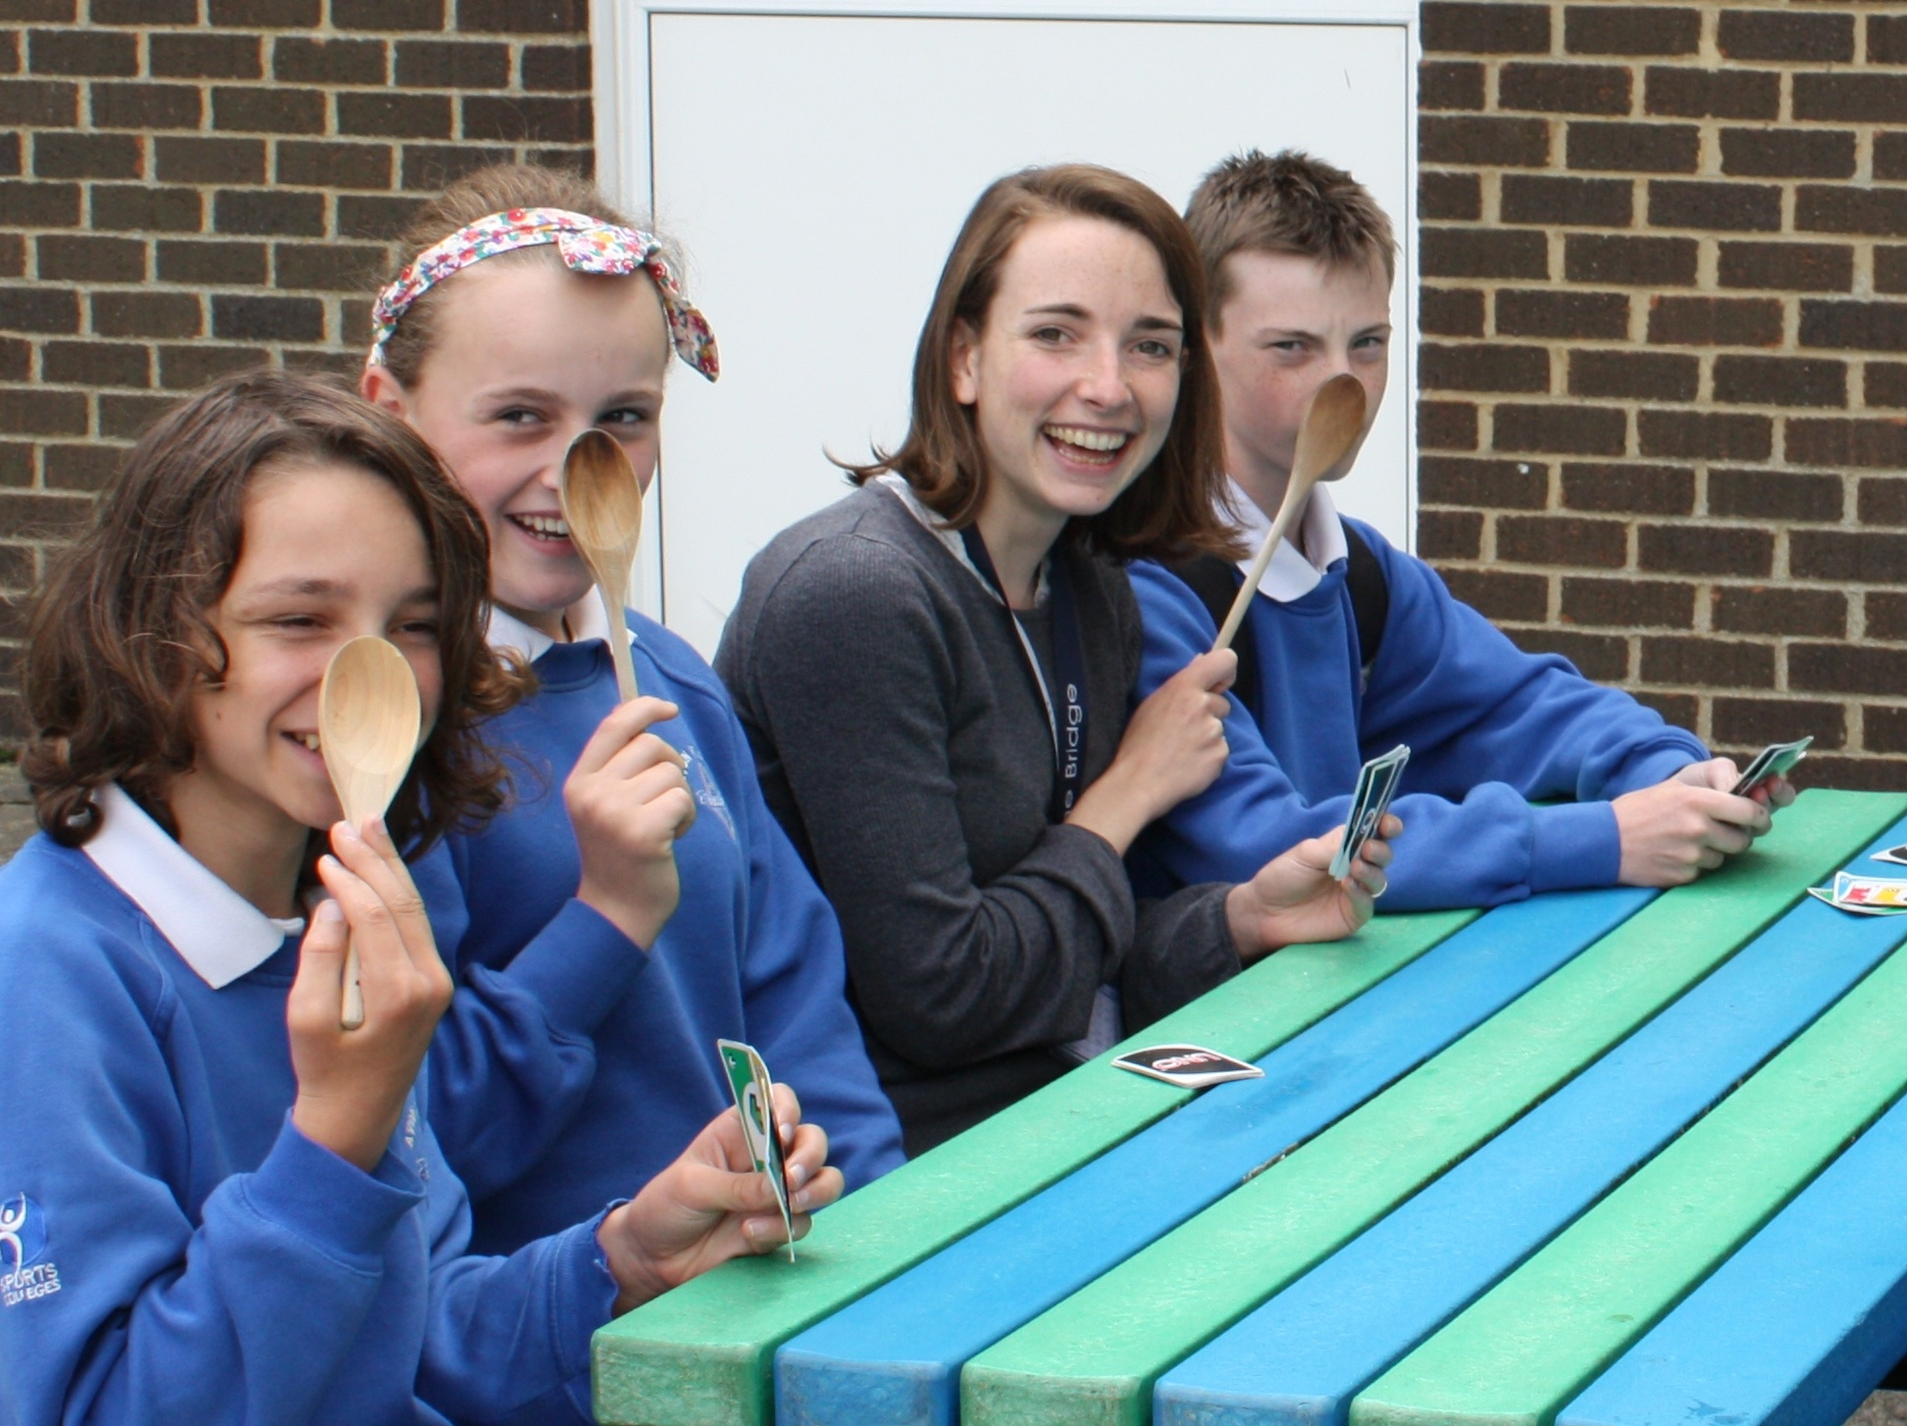

It’s easy to leave a gift in your Will
If you are making a Will or changing an existing one we do strongly recommend that you take professional legal advice. Any gifts you leave to charity will be tax free. The most common types of gifts are:
- A proportion of your estate, expressed as a percentage of the whole
- A cash gift
- A specific item or items eg a house, car, piece of jewellery.
If you wish to include The Bridge in your Will please ensure you use the organisation’s full name, address and registered charity number as below:
The Bridge Youth Project, PO Box 1833, Salisbury, Wilts, SP4 8HH
Registered charity number: 1034800
If you already have a Will you can add in a gift to The Bridge by completing the example Codicil form on the back of this leaflet and taking it to your solicitor, who will advise you and will ensure that it does not conflict with the wishes expressed in your current Will.

If you would like any further information, or if you wish to tell us your intentions regarding a gift in your Will, please call Barbara Morse or Tara Hibbs on 01980 655521 or email them at office@the-bridge.org.uk Anything you tell us will be treated in the strictest confidence and is in no way binding on you if you change your mind.


Donations in your Memory
If you would prefer donations to go to charity rather than having floral tributes, it is a good idea to let your executors know, or to include this in the arrangements for your funeral.
The Bridge’s work has been greatly helped in the past by donations “in memory” of some of its supporters.
We also want to act as a Bridge between today’s youth and the life of our local churches and we provide many opportunities for church members to serve in schools.

